

Name: Abdulrahman Alawadhi
PRN: 25070122008
Branch: CSE
Subject: Programming with Java

ASSIGNMENT No.: 7
TITLE: : Implement a Java program to demonstrate inheritance and interfaces using suitable real-world examples.

Problem Statement:

Implement a Java program to demonstrate inheritance and interfaces using suitable real-world examples.

Learning Objectives:

To implement inheritance and interfaces for achieving code reusability and abstraction.

Theory:

Inheritance allows one class to acquire the properties and methods of another class, promoting code reuse and reducing redundancy. Java supports single inheritance through the extends keyword. Interfaces define a contract that implementing classes must follow, enabling abstraction and multiple inheritance of type. Together, inheritance and interfaces support polymorphism and modular software development. They are fundamental concepts of object-oriented programming.

Outcomes:
Successfully implemented inheritance and interfaces in Java to achieve code reusability and abstraction. Applied these concepts to build real-world applications like a Shape calculator and an E-Commerce Product System.
interface Display {
void showDetails();
}

class Person {
String name = "Abdulrahman";

void greet() {
System.out.println("Hello! Welcome.");
}
}

class Student extends Person implements Display {
int rollNo = 22008;

public void showDetails() {
System.out.println("Name: " + name);
System.out.println("Roll Number: " + rollNo);
}

void study() {
System.out.println("Student is studying Java.");
}
}

public class Main {
public static void main(String[] args) {
Student s = new Student();

s.greet();
s.showDetails();
s.study();
}
}

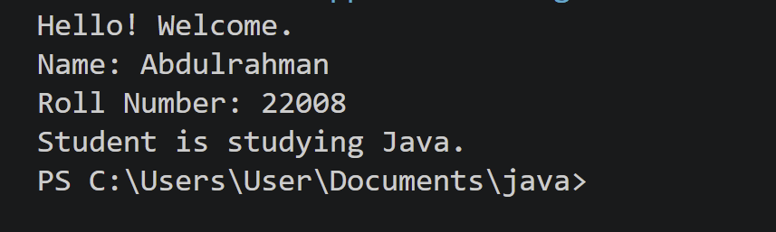

Conclusion:

This assignment demonstrates how inheritance enables code reuse by allowing subclasses to acquire properties and methods from a parent class, while interfaces define contracts that ensure consistent behaviour across different classes. The Shape application and E-Commerce Product System successfully illustrate how these OOP concepts support abstraction, polymorphism, and modular software design in real-world scenarios.

Exercise:

- Create a Shape application where Circle and Rectangle inherit from Shape and calculate area.

class Shape {
void area() {
System.out.println("Area method not defined for generic shape.");
}
}

class Circle extends Shape { double radius; Circle(double radius) {
this.radius = radius;
}
void area() {
double result = Math.PI * radius * radius; System.out.println("Circle Area: " + result);
}
}

class Rectangle extends Shape { double length, width;
Rectangle(double length, double width) { this.length = length;
this.width = width;
}
void area() {
double result = length * width; System.out.println("Rectangle Area: " + result);
}
}

public class JAVA_EXP_7 {
public static void main(String[] args) {

Shape circle = new Circle(5);
Shape rectangle = new Rectangle(4, 6);

circle.area(); rectangle.area();
}
}
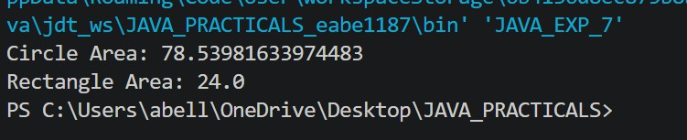

- Develop a E-Commerce Product System where electronic, clothing, and grocery products inherit common properties and implement product interfaces.

interface ProductInfo { void displayDetails();
}

class Product { String name; double price;
Product(String name, double price) { this.name = name;
this.price = price;
}
}

class Electronics extends Product implements ProductInfo { int warrantyYears;
Electronics(String name, double price, int warrantyYears) { super(name, price);
this.warrantyYears = warrantyYears;
}
public void displayDetails() {
System.out.println("Electronics -> " + name + " | Price: " + price + " | Warranty: " + warrantyYears + " yrs");
}
}

class Clothing extends Product implements ProductInfo { String size;
Clothing(String name, double price, String size) { super(name, price);
this.size = size;

}
public void displayDetails() {
System.out.println("Clothing -> " + name + " | Price: " + price + " | Size: " + size);
}
}

class Grocery extends Product implements ProductInfo { String expiryDate;
Grocery(String name, double price, String expiryDate) { super(name, price);
this.expiryDate = expiryDate;
}
public void displayDetails() {
System.out.println("Grocery -> " + name + " | Price: " + price + " | Expiry: " + expiryDate);
}
}

public class JAVA_EXP_7 {
public static void main(String[] args) {
ProductInfo item1 = new Electronics("Smartphone", 25000, 1); ProductInfo item2 = new Clothing("T-Shirt", 599, "M"); ProductInfo item3 = new Grocery("Rice Bag", 450, "Dec-2026");

item1.displayDetails(); item2.displayDetails(); item3.displayDetails();
}
}
